University Examinations 2017/2018

FOURTH Year FIRST Semester Exams for the degree of

Bachelor of Engineering
in
Electrical & Telecommunications Engineering and
Electrical & Electronics Engineering

Course Code: ECE 471
Course Title: POWER SYSTEMS II

Instructions to candidates:
Answer any 5 of the following 7 questions
All questions carry equal marks
Time:3 hrs

1. (a) Give five essential features of a switchgear.
[5 marks]
(bName four components of switchgear equipment.
[4 marks]
(c) Prove that in a three phase system of V_{1,}V₂ and V₃ are the three phase balanced voltages whose phasor sum is zero,the positive and the negative sequence components are expressed as
V_{1p} ={1/√3(V₁ + V₂∠60° )}∠30°
V_{1N =}{1/√3(V₁ + V₂∠-60° )}∠-30°

[5 marks]

2. (a) Name the two types of electrical faults in power systems.
[2 marks]
(b) Give three advantages of using reactors to control short circuit currents
[3 marks]
(c)Give three disadvantages of feeder reactors.
[3 marks]
(d) The bus-bars of a power station are in two sections P and Q separated by a
Reactor as shown in fig,2c. Connected in section P are two 15 MVA generators of 12 % reactance each and to Q one 8 MVA generator of 10% reactance. The reactor is rated at 10 MVA and 15% reactance. Feeders are connected to bus-bar P through transformers, each rated at 5 MVA and 4% reactance. Determine the maximum short-circuit MVA with which circuit breakers on the outgoing side of the transformers have to deal.
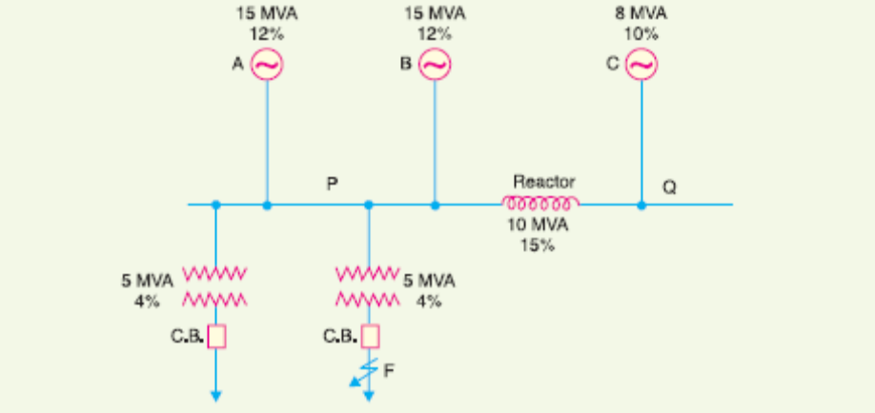
[6 marks]
Fig.2c

3. (a) Give a brief outline of three types of bus-bar arrangement.
[6 marks]

(b) Show that a generating plant having N section bus-bars each rated at Q kVA
with x% reactance, connected on the tie-bar system through bus-bar reactances of b% has a total short-circuit kVA on one section of
[Q/x +(Q(N-1))/bN+x] (Assume tie-bar system)
[4 marks]

(c) In (b) above if the section rating is 50,000 kVA ; x = 20% and b = 10%, find the short-circuit kVA with
(i) 3 sections (ii) 9 sections and (iii) show that with a very large number of sections, the short-circuit kVA would not exceed 7,50,000 kVA.
[4 marks]

4. (a) Give a brief outline on the three types of fuses.
[6 marks]
(b) Derive from the first principles the of fault current and phase voltages under the following conditions (i)Line-Line fault (ii)Double line to Ground fault.
[8 marks]

5. (a) A balanced star connected load takes 90 A from a balanced 3-phase, 4-wire
supply. If the fuses in the Y and B phases are removed, find the symmetrical components of the line currents
(i) before the fuses are removed (ii) after the fuses are removed.
[4 marks]

(b) Develop the zero, positive and negative sequence network of fig,5b .
Given T₁=j0.20Ω,L₁ =L₂=L₃=0,3472Ω,T₂ =j0.08Ω,T₃=j0.20Ω
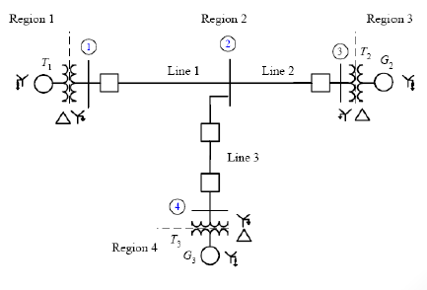
Fig.5b

[6 marks]
(c) Three impedances of 5—j10, 6 + j 5 and 3 + j15 ohms are connected in star to
red, yellow and blue lines of a 3300 V, 3-phase, 3-wire supply. The phase sequence is RYB. Calculate the line current I_{R}.
[4 marks]
6. (a) Define the following terms as applied to circuit breakers;
(i)Arc voltage
(ii)Restriking voltage
(iii)Recovery voltage
[3 marks]

b)Explain three advantages and three disadvantages of using oil as an arc quenching medium.
[6 marks]

c)A 50Hz, 11kv,3-phase alternator with earthed neutral has a reactance of 5Ω per phase and is connected to a bus-bar through a circuit breaker.The distributed capacitance upto circuit breaker between phase and neutral is 0.01µF.Determine
(i)peak re-striking voltage across the contacts of the breaker
(ii)frequency of oscillations
(iii)the average rate of rise of re-striking voltage upto the first peak.
[5 marks]

7. (a) What is a protective relay?
[1 mark]

b)State and explain six fundamental requirements of protective relay.
[6 marks]

c)Explain with the help of a neat diagram the principle behind the operation of induction type directional overcurrent relay. [7 marks]

------------- END OF EXAM -------------

